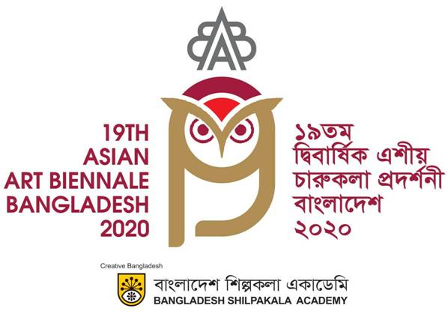 |  | 1 November to 31 December 2021  www.asianartbiennale.org.bd

Country Name | Delegate’s Details |  | Flight Details | Arrival & Departure Schedule
 | Full Name |  | Name of Airways | Depart from
 | Passport No
 | Gender |  |  | On 00/00/0000 at 00.00
 | Type of Delegate |  | Flight No. (Arrival) | am/pm to HSIA
 | Address |  |  | Dhaka, Bangladesh.
 |  |  | Flight No. (Departure) | Depart from
 | Phone No |  |  | HSIA, Dhaka, Bangladesh
 | Email Id |  |  | On 00/00/0000 at 00.00
 | Emergency Contact |  |  | am/pm to

